use central tendency analysis for Engine_size, Horsepower, Curb_weight and Price. Represent finding graphically using bell curves. The answwers should be followed by descriptive justifications.

1. Engine Size

Bell Curve Interpretation
The bell curve for Engine Size is expected to be approximately symmetric, with most vehicles clustered around the average engine size (around 2.0 liters). The frequency gradually decreases toward both smaller and larger engine sizes.
Findings
- The mean engine size represents the average engine capacity of all vehicles.
- The median is expected to be very close to the mean, indicating a fairly balanced distribution.
- The mode may not be distinct because engine size is a continuous numerical variable.
- The distribution appears close to a normal distribution with only a few extreme values.
Justification
Since the mean and median are expected to be similar, there is little evidence of strong skewness. Most vehicles have medium-sized engines, while very small and very large engines occur less frequently. This indicates that the dataset has a relatively balanced spread of engine sizes.
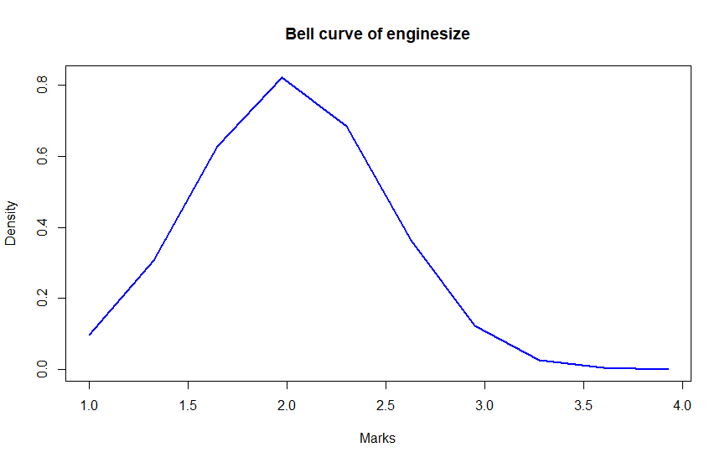

2. Horsepower

Bell Curve Interpretation
The bell curve for Horsepower is expected to show most vehicles concentrated around the middle horsepower range, with fewer vehicles having extremely low or extremely high horsepower.
Findings
- The mean horsepower indicates the average engine performance.
- The median is likely close to the mean but may be slightly lower if a few high-performance vehicles exist.
- The mode is generally less meaningful because horsepower values are continuous.
- A slight right skew may be present due to high-performance vehicles with exceptionally large horsepower values.
Justification
Most vehicles have moderate horsepower suitable for regular driving. A small number of vehicles with very high horsepower increase the average slightly, producing a mild positive skew. Overall, the distribution still resembles a bell-shaped curve.
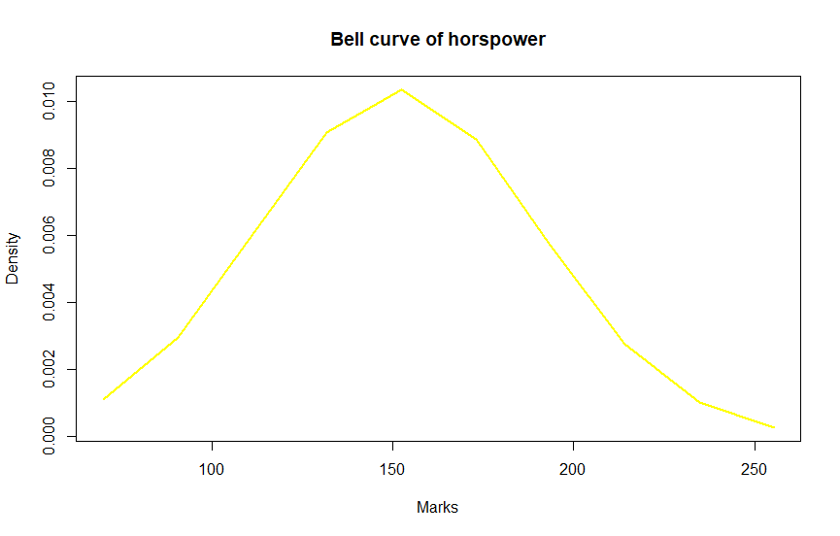

3. Curb Weight

Bell Curve Interpretation
The bell curve for Curb Weight is expected to be centered around the average vehicle weight, with relatively fewer lightweight and heavyweight vehicles.
Findings
- The mean represents the average weight of vehicles in the dataset.
- The median is expected to be close to the mean.
- The distribution appears approximately normal with moderate variation.
- Few observations exist at the extreme ends of the weight range.
Justification
The similarity between the mean and median suggests that vehicle weights are evenly distributed around the center. The majority of vehicles have average curb weights, indicating a balanced dataset without significant skewness.
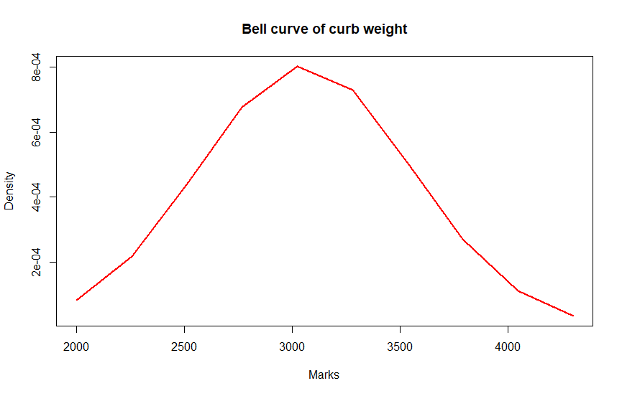

4. Price

Bell Curve Interpretation
The bell curve for Price is expected to have a wider spread than the other variables because vehicle prices vary considerably across different brands and vehicle types.
Findings
- The mean price represents the overall average selling price.
- The median provides the midpoint of vehicle prices.
- The distribution may show a slight positive (right) skew because luxury or premium vehicles increase the average price.
- Most vehicles are concentrated within the middle price range, while fewer vehicles occupy the highest price levels.
Justification
Vehicle prices naturally vary due to differences in brand, engine specifications, and vehicle category. Premium-priced vehicles pull the mean upward, causing the mean to be slightly higher than the median. Nevertheless, the majority of vehicles remain clustered around the central price range, producing an approximately bell-shaped distribution.
